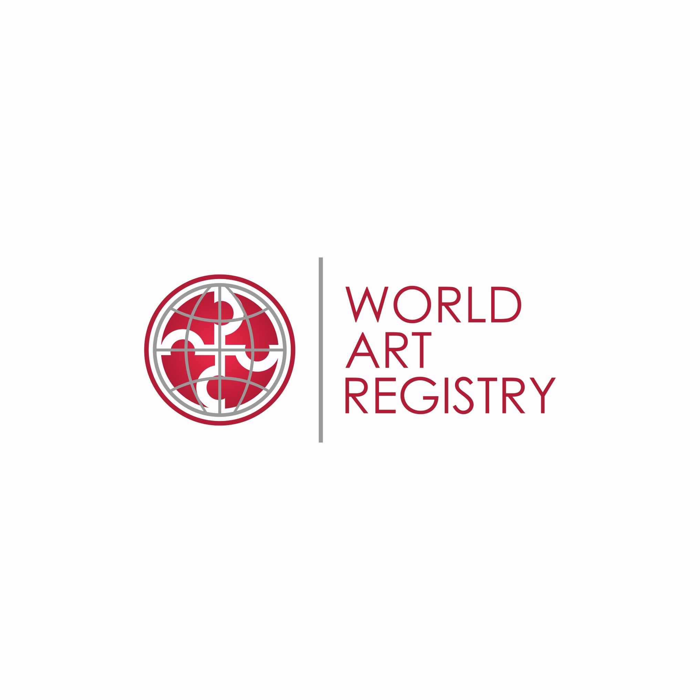CERTIFICATE OF AUTHENTICITY AND OWNERSHIP TRANSFER

This document certifies that the artist declares the piece of Artwork titled below with **WORLD ART REGISTRY ID NUMBER XXXXX** to be an authentic, original and unique piece of art of her / his own creation efforts and executed by her / him, the undersigned.

The artist retains all copyright. Artwork may not be reproduced without the artist’s consent.

IMAGE OF ARTWORK

**Artist:**  *Name of Artist*

**Title:**  *Title of the work*

**Year of completion:** *Year the artwork was created*

**Medium:**  *What is the artwork made of*

**Edition:**  *Edition details, if applicable*

**Original / Reproduction:** *specify whether original or reproduction*

**Special instructions:**  *any special instructions regarding the condition of the work, installation instructions, etc*

Ownership of the above titled artwork has been transferred to:

(NAME)

(ADDDRESS)

on the sum of (XXXX)

paid as an advance toward the total price of (XXXX)

on (DATE).

All information and statements contained herein are true and correct.

Signature of Artist Place and Date